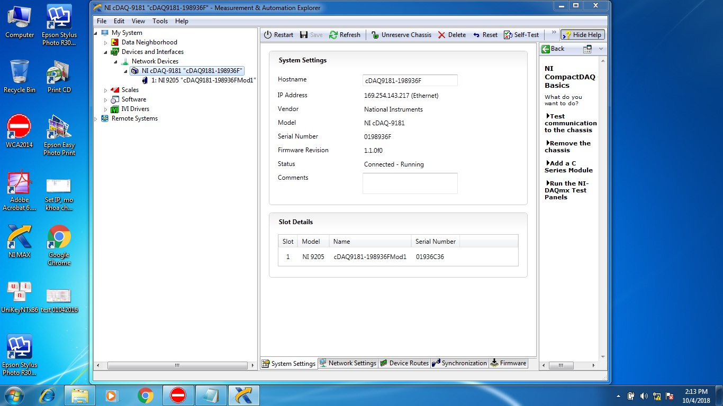

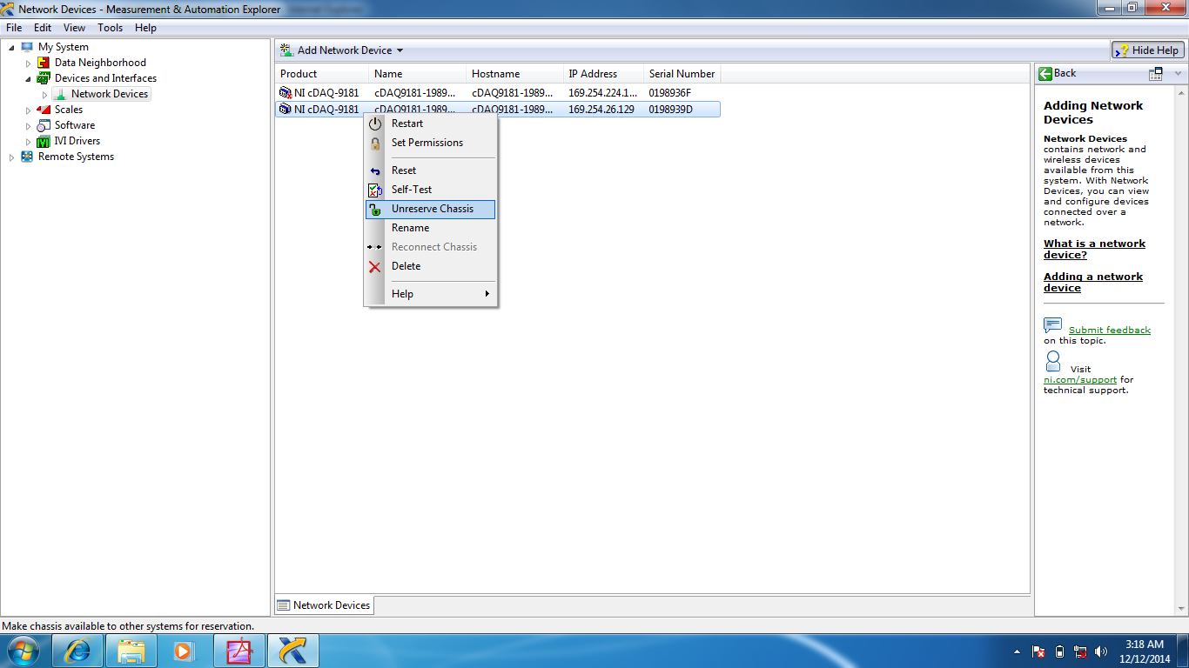

NI_Gain=2
Dev1=cDAQ9181-198936F,198936F,Box 2,169.254.224.169,0
Dev2=cDAQ9181-198936FMod1,1936C36,Box 1,169.254.224.169,1

